Cat E: Servlet and JSP

E1- Write a JSP program to check whether entered number is even or odd.

**Code:**

**input.jsp**

<%@ page language=*"java"* contentType=*"text/html; charset=UTF-8"*

pageEncoding=*"UTF-8"*%>

<!DOCTYPE html>

<html>

<head>

<meta charset=*"UTF-8"*>

<title>Insert title here</title>

</head>

<body>

<form action=*output.jsp*>

<pre>

Enter any no.<input type=*text* name=*t1*><br>

<input type=*submit*> <input type=*reset*>

</pre>

</form>

</body>

</html>

**output.jsp**

<%

String s=request.getParameter("t1");

**int** n=Integer.parseInt(s);

**if**(n%2==0)

out.println("<h1>Number is even.");

**else**

out.println("<h1>Number is odd.");

%>

</body>

</html>

**Output:**

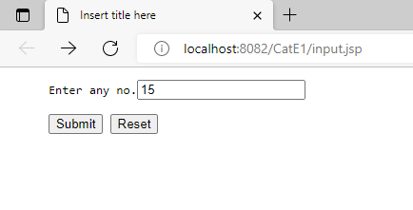

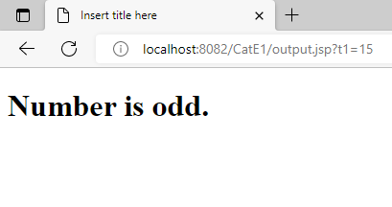

E2-Write a JSP program to print table of any number.

**Code:**

**input1.jsp**

<%@ page language=*"java"* contentType=*"text/html; charset=UTF-8"*

pageEncoding=*"UTF-8"*%>

<!DOCTYPE html>

<html>

<head>

<meta charset=*"UTF-8"*>

<title>Insert title here</title>

</head>

<body>

<form action=*output1.jsp*>

<pre>

Enter any no.<input type=*text* name=*t1*><br>

<input type=*submit*> <input type=*reset*>

</pre>

</form>

</body>

</html>

<%@ page language=*"java"* contentType=*"text/html; charset=UTF-8"*

pageEncoding=*"UTF-8"*%>

<!DOCTYPE html>

<html>

<head>

<meta charset=*"UTF-8"*>

<title>Insert title here</title>

</head>

<body>

**output1.jsp**

<%

String s=request.getParameter("t1");

**int** n=Integer.parseInt(s);

**for**(**int** i=1;i<=10;i++)

out.println("<h1><b>"+n+"*"+i+"="+(n*i)+"</h1></b>");

%>

</body>

</html>

**Output:**

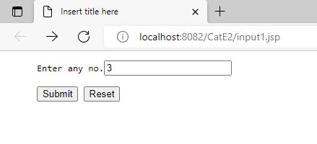

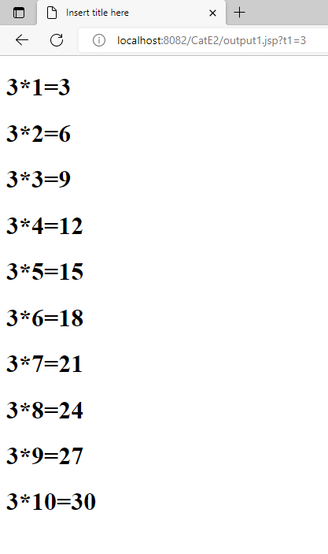

E3-Write a JSP program to accept number from user and using servlet perform +, -, * and /

**Code:**

**input2.jsp**

<%@ page language=*"java"* contentType=*"text/html; charset=UTF-8"*

pageEncoding=*"UTF-8"*%>

<!DOCTYPE html>

<html>

<head>

<meta charset=*"UTF-8"*>

<title>Insert title here</title>

</head>

<body>

<form action=*SumServlet* method=*get*>

<pre>

Enter any no.<input type=*text* name=*t1*>

Enter any no.<input type=*text* name=*t2*><br>

<input type=*submit*> <input type=*reset*>

</pre>

</form>

</body>

</html>

**SumServlet**

package add;

import jakarta.servlet.ServletException;

import jakarta.servlet.annotation.WebServlet;

import jakarta.servlet.http.HttpServlet;

import jakarta.servlet.http.HttpServletRequest;

import jakarta.servlet.http.HttpServletResponse;

import java.io.IOException;

import java.io.PrintWriter;

/**

* Servlet implementation class SumServlet

*/

public class SumServlet extends HttpServlet {

private static final long serialVersionUID = 1L;

/**

* @see HttpServlet#HttpServlet()

*/

public SumServlet() {

super();

// TODO Auto-generated constructor stub

}

/**

* @see HttpServlet#doGet(HttpServletRequest request, HttpServletResponse response)

*/

protected void doGet(HttpServletRequest request, HttpServletResponse response) throws ServletException, IOException {

// TODO Auto-generated method stub

String s1=request.getParameter("t1");

String s2=request.getParameter("t2");

double n1=Double.parseDouble(s1);

double n2=Double.parseDouble(s2);

PrintWriter out=response.getWriter();

response.setContentType("text/html");

out.println("<h1>Addition is "+(n1+n2));

}

/**

* @see HttpServlet#doPost(HttpServletRequest request, HttpServletResponse response)

*/

protected void doPost(HttpServletRequest request, HttpServletResponse response) throws ServletException, IOException {

// TODO Auto-generated method stub

}

}

**Output:**

